Build a Tab with Single-Sign-On Support
- Set up your Azure AD application

The first thing that we need to do is to register a new Azure Active Directory application in the Azure AD portal, that will represent your Microsoft Teams tab. You do this by signing in to https://aad.portal.azure.com using a set of credentials that is allowed to register new applications. Then navigate to Azure Active Directory and chose App Registrations in the left-hand side menu.

Create a new application by clicking on + New registration - on this first screen you choose the name of your application and what account types you would like to support - choose any of the Account sin any organizational directory... options. Finally click on Register.
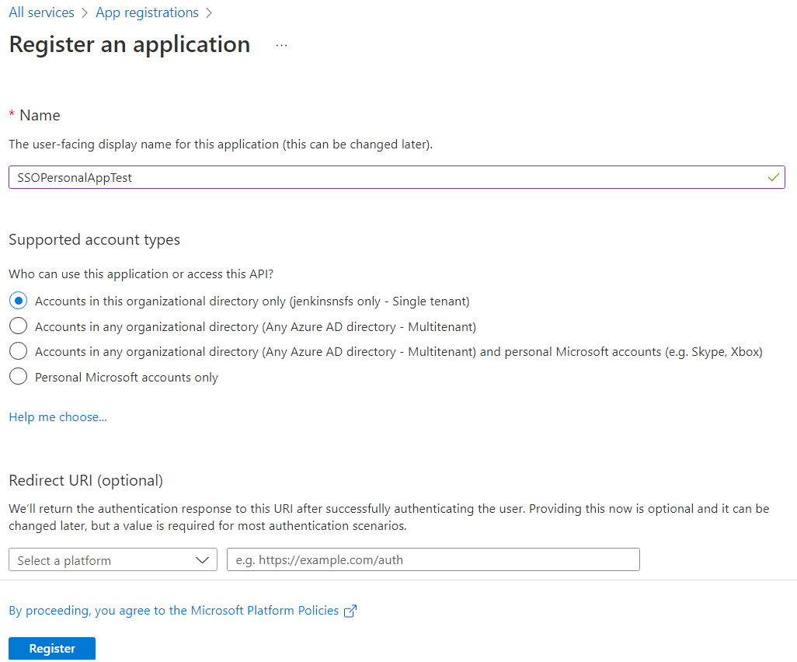

After the registration you will be redirected to the Application page where you can find the Application (client) ID, copy this ID into a temporary location such as notepad as you will need it shortly.

The next thing we need to do is to go to Expose an API
- Add application ID URI
The Application ID URI MUST have the following format: api://<your host name>/<application id>
- Add scope
You create scope by clicking at Add a scope. Name it access_as_user and choose that both Admins and users can consent. Then you need to write the user-friendly consent display names and descriptions before clicking Add scope.
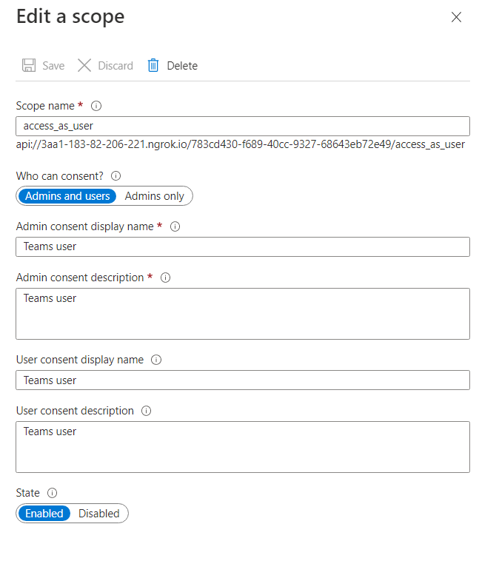
- Add a client application
1fec8e78-bce4-4aaf-ab1b-5451cc387264 - the ID used by the Microsoft Teams desktop and mobile application
5e3ce6c0-2b1f-4285-8d4b-75ee78787346 - the ID use by the Microsoft Teams web application
API Permission
The final configuration we need to do is to grant permissions to the Tab App registration. This is done by navigating to API Permissions and then click on Add a permission. All the permissions we need is in Microsoft Graph, so select that and then we also need to choose that we want to use Delegated Permissions. The permissions you need to select are the following:
- User.Read - should already be selected when the app was created
- email
- offline_access
- openid
- profile

That's it! Now we are ready to scaffold out our Teams Tab project.

Create your App
Start the Microsoft Teams App generator by invoking the yo teams command. Follow the instructions and input name of your solution and package.
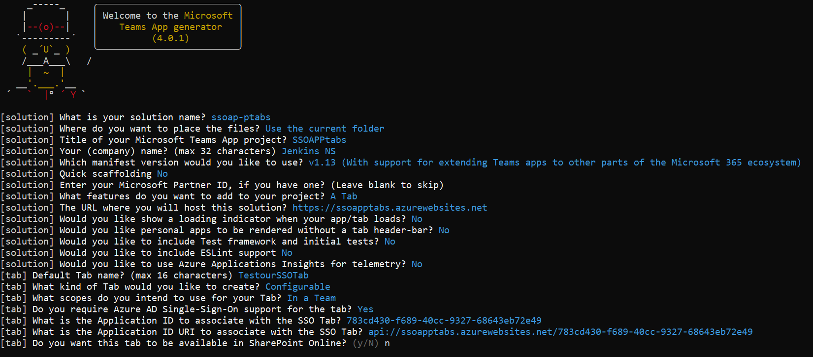

Update below code in manifest file webApplicationInfo section
"webApplicationInfo": {
"id": "{{TAB_APP_ID}}",
"resource": "api://{{PUBLIC_HOSTNAME}}/{{TAB_APP_ID}}"
}

Go to code, Client SSOtesttab ssotesttab.tsx file
Line number 21 update below code
resources: ["api://", process.env.PUBLIC_HOSTNAME as string, "/" , process.env.TAB_APP_ID as string],

Build the application
gulp ngrok-serve
Then copy the ngrok new domain url example : fb62-183-82-206-221.ngrok.io
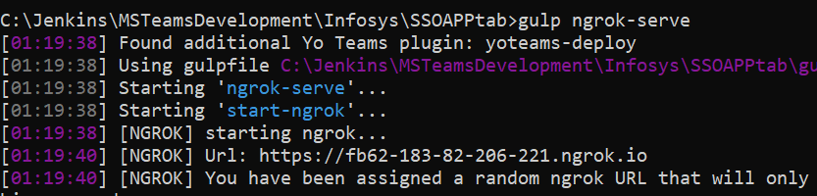

Then update this url in azure Application ID URI
To
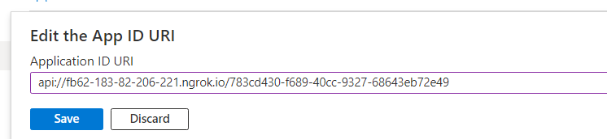
Save it
Then upload the app package in teams and test it

